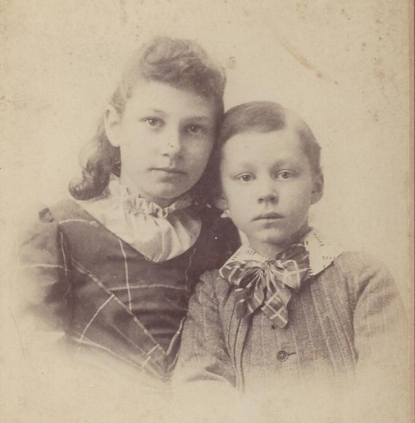

Anne Foster Stickney & Harry Foster, Mary Helen Foster Wolfe’s

half-sister and half-brother – about 1890 (est.)

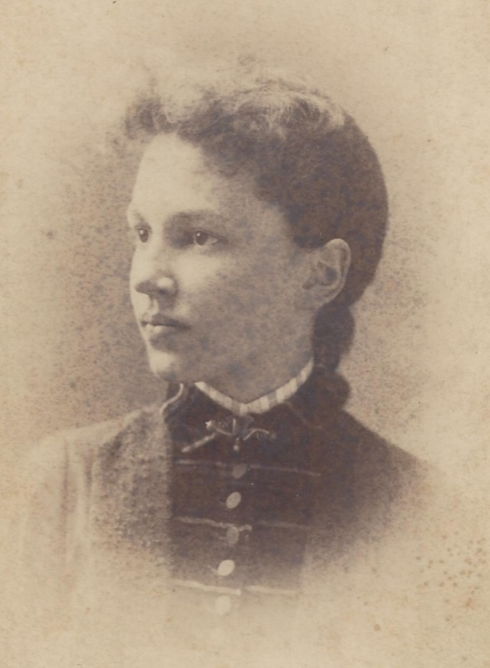

Anne Foster Stickney, Mary Helen Foster Wolfe’s

half-sister - abt 1905 (est.)